
DISCLOSURE BARRING SERVICE: DISCLOSURE STATEMENT

Allerton Grange Policy
Statement on the recruitment of ex-offenders

It is a legal requirement that all registered bodies and prospective employers must treat DBS applicants who have a criminal record fairly and not discriminate because of a conviction or other information revealed. Registered Bodies and employers who are Regulated Activity Providers (including schools) are obliged to have a written statement/policy on the recruitment of offenders, which is available to DBS applicants at the outset of the recruitment process.

- Allerton Grange is committed to the fair treatment of its staff, potential staff or users of its services, regardless of race, gender, religion, sexual orientation, responsibilities for dependants, age, physical/mental disability or offending background.

- Allerton Grange School actively promotes equality of opportunity for all with the right mix of talent, skills and potential and welcomes applications from a wide range of candidates, including those with criminal records. We select all candidates for interview based on their skills, qualifications and experience.

- As an organisation using the Disclosure and Barring Service (DBS) checking service to assess applicants’ suitability for positions of trust, Allerton Grange must fully comply with this Code of Practice and treat all applicants for positions fairly. There will be no unfair discrimination against any subject of a Disclosure on the basis of conviction or other information revealed.

- As a Regulated Activity Provider (RAP) all employees of Allerton Grange School are in regulated activity and therefore subject to checks with the DBS. 6. In relation to volunteers and contractors, we only request a DBS check after a review of the risks involved. For those positions where a DBS is required, all application forms, job adverts and recruitment briefs will contain a statement that a DBS will be requested in the event of the individual being offered the position.

- Applicants who are shortlisted will be required to provide details of any convictions, cautions, reprimands or final warnings as defined by the Rehabilitation of Offenders Act 1974 (Exceptions) Order1975 (as amended in 2013). The amendments to the Exceptions order 1975 (2013) provide that certain spent convictions and cautions are ‘ protected’ and are not subject to disclosure to employers, these cannot be taken into account. The amendments to the Rehabilitation of Offenders Act 1974 (Exceptions) Order 1975 (2013 and 2020) provides that when applying for certain jobs and activities, certain convictions and cautions are considered ‘protected’. This means that they do not need to be disclosed to employers, and if they are disclosed, employers cannot take them into account.Guidance about whether a conviction or caution should be disclosed can be found on the Ministry of Justice website.Shortlisted candidates will be sent a self-disclosure form and asked to return this to recruitment@allertongrange.com prior to interview/assessment. Candidates will be asked to sign a copy of this Application Form and their self – disclosure prior to interview. Please see the Information for Applicants regarding what should be disclosed and what is protected under the Act and should not be disclosed. Further information and guidance can be found on the Disclosure and Barring Service website.

- We ensure that everyone in our school who are involved in the recruitment process has been suitably trained to identify and assess the relevance and circumstances of offences. We also ensure that they have received appropriate guidance on the relevant legislation relating to the employment of ex-offenders, e.g. the Rehabilitation of Offenders Act and know how to access advice and support e.g. from our Registered Body.

- At interview, or on a separate occasion, we ensure that an open and measured discussion takes place on the subject of any offences or other matter that may be relevant to the position. Failure to reveal information that is directly relevant to the position sought could lead to withdrawal of an offer of employment. We undertake to discuss any matter revealed in a DBS check with the person seeking the position before considering withdrawing a conditional offer of employment. This discussion and any subsequent risk assessment may be undertaken by our HR Director, or another trained member of our Senior Leadership Team or Registered Body.

- A summary of this written policy on the recruitment of ex-offenders is made available to all DBS applicants at the outset of the recruitment process, by inclusion in the information pack for applicants and being visible on our website.

- Having a criminal record will not necessarily bar you from working with us. This will depend on the nature of the position and the circumstances and background of your offences.

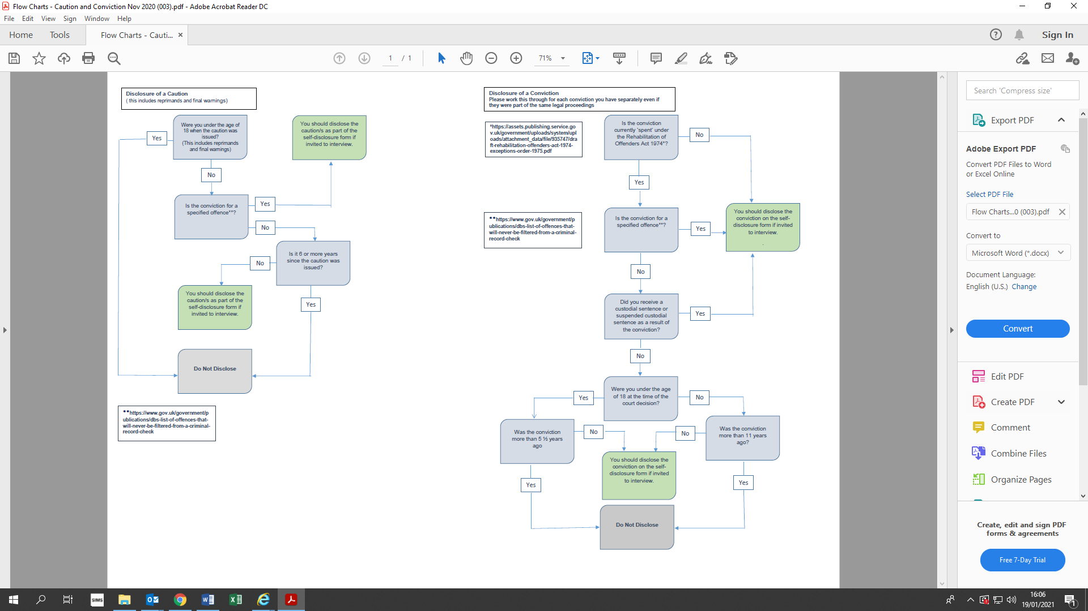
Flow Chart for Disclosure of a Conviction and/or Caution

